Geoprogramming Workflows

* How close to nearest evacuation route
  1. Census Blocks 🡪 Centroids using Feature to Point
  2. Match projections
  3. Clip roads to svi_tx shapefile extent
  4. Intersection of Roads and Evacuation routes as on ramps 🡪 Ramp points
  5. Roads to Network Dataset (from Assignment 7)
  6. Fastest path from centroids to ramp points using Closest Facilities Analyst

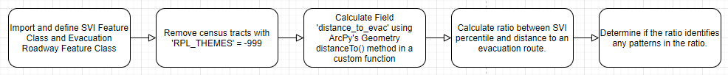

* Do Census Tracts which rank higher on the SVI flood more easily?
  1. Spatial Joins of high-water marks and census block groups
  2. Summary statistics of high-water mark points in each census block group
  3. Maybe some ratios?
  4. Some fun visualization?

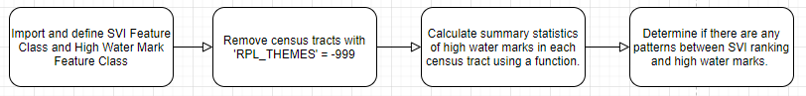

* Do Census Tracts which rank higher on the SVI incur building damage more easily?
  1. Spatial Joins of building damage points in each census block group
  2. Summary statistics of building damage points in each census block group
  3. Some ratios?
  4. Some fun visualization?

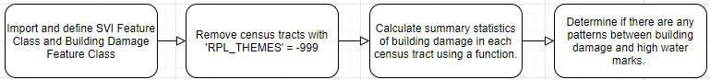

All data will be used in this project and to provide updated data for geographic visualization project.